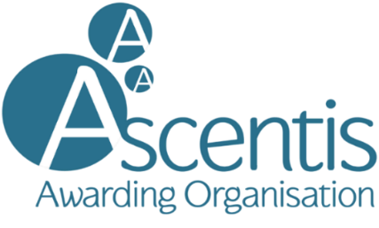
New Centre Expression of Interest
International Centres

The expression of interest allows an early decision to be made as to whether the centre should proceed to centre recognition.

Before completing this form, you must review the qualification specification and Ascentis Centre Agreement to ensure all requirements can be met.

Following a review of this form by Ascentis, the outcome will be one of the following:

- Permission to apply for full centre recognition is granted i.e. with all the chosen qualifications listed
- Permission to apply for approval to deliver some of the qualifications listed
- Postponement of any further application to a stated date
- No further application permitted

Centre Information
Centre Name: |  | Date of Enquiry:
Centre Address:
Contact Name: | Job Title:
Contact Telephone: | Contact Email Address:
Centre Website Address:
Type of Provider:
How long have you been trading?

How did you hear about Ascentis?

About your existing provision
Complete the table below if your centre has been recognised by any Awarding Organisation for the delivery of qualifications.
Qualification Title | Accrediting Awarding Organisation

Initial Qualification Approval:
Please list the Ascentis qualifications you wish to deliver:
*Currently we do not offer ESOL qualifications internationally
Qualification Title | Anticipated Numbers

Recruitment & Delivery
How would learners be recruited for the qualification(s)?
Outline how the qualification(s) will be delivered and assessed?
What are your staffing arrangements?

PLEASE RETURN THE COMPLETED FORM TO:

international@ascentis.co.uk

FOR ASCENTIS USE ONLY
International (QA, Product Development, Commercial) | Date form received in office:
Quality Assurance | Allocated QA Manager:  QAM Recommendations & Date: | QAM Notes:
Quality Assurance | Supported by the Senior Quality Assurance Manager (signature & date):
Leadership Team | Approved by Leadership Representative (signature & date):
Awarding/Commercial | Outcome communicated to centre (date):

